Sound Design Concept

Kerui Huang 1463475

**Stimulus:**

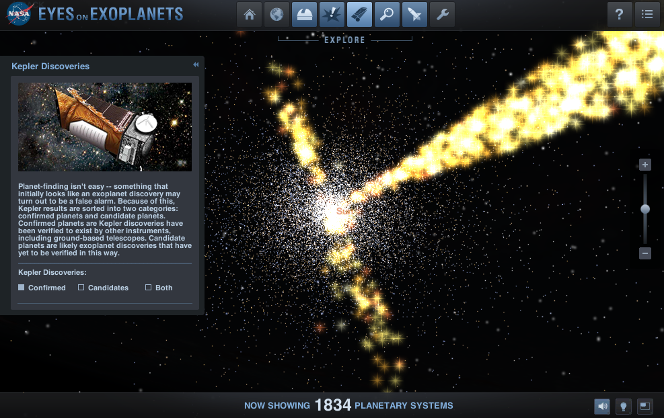

<https://exoplanets.nasa.gov/eyes-on-exoplanets-web/>

<Figure 1: Eyes on the Exoplanets>

NASA’s “Eyes on Exoplanets” (figure 1), initially released in 2010 is a 3D web application that incorporates all current known planetary systems in a scientifically accurate, fully rendered interactive universe.

This program additionally undergoes daily updates based on the latest data recorded in the official NASA exoplanet archive, also used by professional astronomers around the world.

With the latest data showing more than 5500 confirmed exoplanets in over 4000 planetary systems, NASA's mission of space exploration and search for life symbolises an optimistic outlook and our unending effort to learn in an infinite universe.

This system is currently accessible real-time via desktops, smartphones or tablets through a web-based App. The input methods include touchpads, mouses, and the keyboard, while the interactive perspective of the 3D universe is displayed as the output. Currently, no sound is present in this unique digital site.

For a better immersive experience, I propose a sound design to be fitted together with "Eyes on Exoplanets". In doing so, a new sense is added as the stimulant, which can be significant in an already limiting digital environment.

**Sound Concept**

In my proposal, it is intended that the audience enter a mental weightless trance-like state in the environment that can be described as "hypnotic, tranquil and moving". For this site of limitless outer space, where one can perceive both everything and nothing at the same time, the subtle hovering soundscape is appropriate. Such a space allows the audience to meditate, introspect, relax or ponder about our purpose in the boundless universe.

Hence, the sound integrated with the site will be an arrangement of the genre *space ambient*.

As described by producer Arthur Kody on an *Izotope* (Audio production software) article , Ambient music is generally characterized by smooth prolonged tones, layered sounds and a lack of a consistent beat, especially known for its ability to craft a spatial experience for listeners. A quote by Jon Dale, head tutor from University of Melbourne in his article "An introduction to Ambient Music" published on the Barbican art centre website, further states that the sound of ambient music should be "as ignorable as it is interesting".

From an in-depth research about ambient music associated with space, a number of works and artists were found to be especially significant in its development and modern application:

The first implementation of the general ambient music was by Musician Brian Eno in his studio album "Ambient 1: Music for Airports". The track mainly included instrumental loops of bright elongated piano and an echoing synthesizer, intended to relieve the tense atmosphere in an airport terminal.

Following the trend, composer Mort Garson's soundtrack for the *CBS footage of the Apollo 11 moon landing in 1969* primarily assembled using synthesizers, pioneered the link between space exploration and this genre.

In 1973, the weekly radio show with "a collection of Ambient, Space, and Contemplative music from around the world and across the centuries" named Hearts of Space was created by producer Stephen Hill, promoting "calm, concentration and deep listening". Within the show, late works from the '70s ambient producers such as Tangerine Dream, Klaus Schulze, and Jean-Michel Jarre, as well as tracks from modern artists Steve Roach, Robert Scott Thompson and Melanohelios were presented to the public.

Steve Roach's five-hour record *Bloodmoon Rising 2014-15* recorded after that night's blood moon lunar eclipse primarily included a muffled introspective drone, through which a sensation of "hopelessly drifting through the void" was depicted.

In contrast, Robert Scott Thompson's *Pale Blue Dot,* utilising clanging bells, rippling water noises and fluctuating synthesizers and more, portrays space's weightlessness and boundlessness through its variable soundscapes.

In highlighting the efforts of space exploration, *steps* by Melanohelios sonically retells the second *space flight of Discovery* (STS-51-A). Pairing the NASA radio recordings with a sparse arrangement of smooth synthetic strings, Melanohelios presents the universe as a grand yet perplexing space.

**Sound Design Proposal**

All sounds used in the sound design are from the public sound library available on Garageband.

All sound editing with compilation will be performed on Garageband.

All tracks will be accessible for unimelb accounts via google drive:

<https://drive.google.com/drive/folders/1mESlZ58ZUPOCT088nrnmw20EqaUUGI19?usp=drive_link>

Taking inspirations from the aforementioned works and advice from Arthur Kody, the design will incorporate tones with reverb, delay or echo and an overall sense of movement to portray an evolving atmosphere.

By the description of Christian Schubart in *Ideen zu einer Aesthetik der Tonkunst* (1806) on the topic of aural characteristics of different musical keys, translated by Rita Steblin in *A History of Key Characteristics in the 18th and Early 19th Centuries* (1983 UMI Research Press), the key of G major is able to express "every gentle and peaceful emotion of the heart". The tranquillity of an infinitely expanding universe evokes this feeling, thus, the ambient design will be set in G major to enhance the site.

The tempo of the sound design is insignificant due to the lack of a beat, which is appropriate for the space ambient music, since it is intended that the audience become unaware of the passing time and be immersed in NASA's rendition of the universe.

Within the application, the soundscape will have 3 main variations depending on the scale of the display and the position of the user. Each screen will be classified with the scale "planet" (when only one planet/star is in view), "planet system" (when a planetary system is in view), or "Universe" (when multiple Planetary systems are in view). The smaller the scale is, the sparser the sound design will become. This follows the logic of an orchestral setting, where each instrument/player contributes to the overall harmony of the piece. When focusing solely on one instrumental part, the music becomes thinner but more coherent. Similarly, when the user is zoomed in on a single planet/star, its individual sound will become clearer and overall less dense. By climbing the scale to "Universe", other varying instruments with the same parts will be added, acting as support in unison with the core "Planet" sound.

The design will be made up of 3 main parts: Bass, melody and effects. Each will be unpacked in detail.

**Bass**

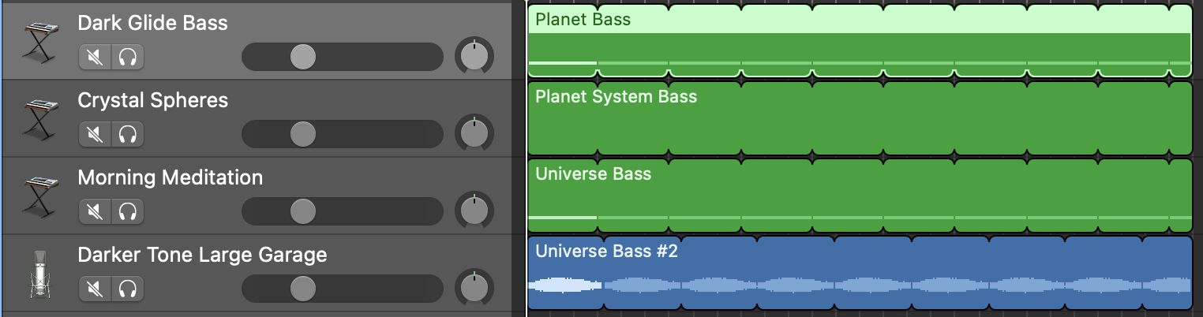

<Figure 2: Bass section>

**Planet Bass** - Dark Glide Bass

Characterized by its consistent and deep tone, *Dark Glide Bass* was suitable to be the underlying bass both in a "Planet" scale and in a "Universe" scale. It acts as the firm support of the sonorous ambience before the layering.

**Planet System Bass** - Crystal Spheres

With an unsteady growling tone in its low register, this Garageband Soundscape additionally provides ornamentations such as twinkling rings of crystal. This provides a suitable second support over the "Planet Bass" while adding a unique rumble to the section.

**Universe Bass** - Morning Meditation

The low register of this Garageband soundscape is made up of a tubular hollow resonance and a deep screech which oscillates in waves. Further adding a sense of disorder in the labyrinthine universe, it complements and enriches the diversity of sounds in the "Universe" scale.

**Universe Bass #2** - Desktop Fan - Darker Tone Large Garage

As an additional Bass in the "Universe" scale, I recorded the humming motor of a desktop Fan, which by chance also produced a G1 note. After combining the recording with the reverb effect *Darker Tone Large Garage* and boosting the lower frequencies up in EQ*,* I was able to produce a whirring oscillating drone which further complements the Bass section.

The entire bass section will be playing G1 simultaneously to convey the permanence and the unwavering stability of the universe. Despite its complexity and disorderedness, the universe is an eternal and immutable space where everything is built upon.

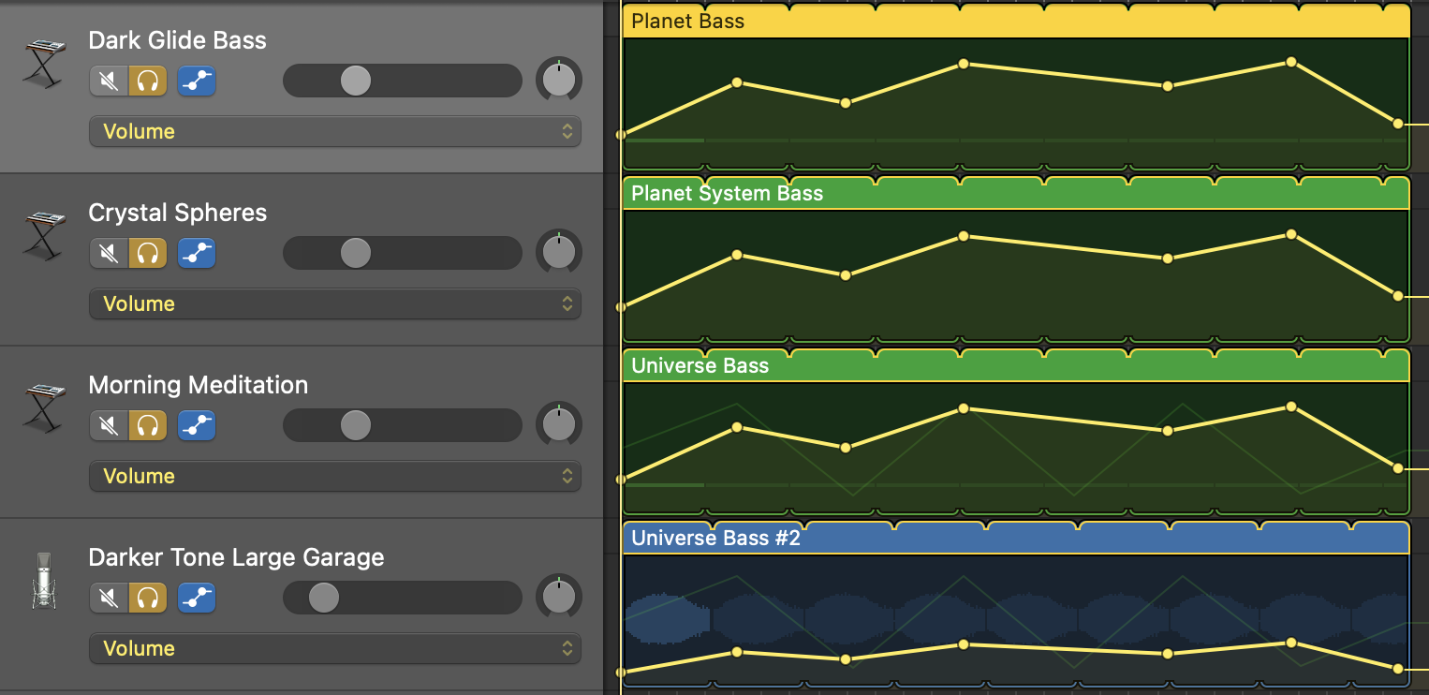

<Figure 3: Bass volume automations>

The same pattern of volume automation is placed on the Bass section to create an undulating swell that heightens the sensation of listeners, with volume of Universe Bass #2 being overall lower to prevent an overwhelming buzz that overshadows the other parts.

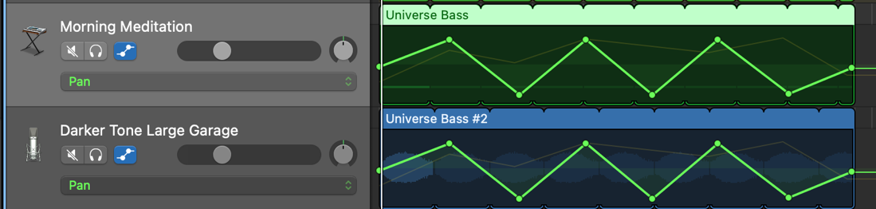

<Figure 4: Bass pan automations>

Additionally, an oscillating Pan automation is added specifically to the "Universe Bass" section, which produces a drone that swings between the left output and the right output (left ear and right ear), giving the impression of movement and hence an unfolding Universe.

**Melody**

The ambient melody is a vague and obscure addition to the Bass foundation, in that the idea of the melody should remain unobtrusive rather than taking the spotlight. In this sound design two melodies excerpts are produced and can be mixed together or used independently to each other in combination with the other parts. This allows variation in the soundscape and contributes towards the idea of an eclectic universe.

**Melody #1**

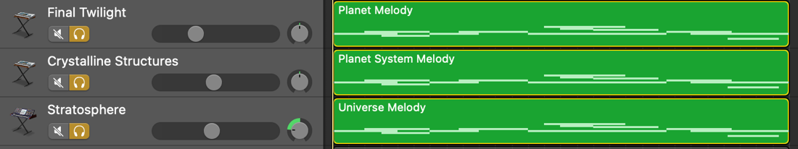

<Figure 5: Melody #1>

**Planet Melody #1** - Final Twilight

With its mellow and rich tone in the high register, *Final Twilight* provides a projecting foundation to the melody line. Combined with vibrato, the resonating melody further complements the firm voice of the "Planet Bass".

**Planet System Melody #1** - Crystalline Structures

In its high register, the *Crystalline Structures* produces a bright and sharp, organ-like tone with occasional jingles that resembles crystalline objects, as the name suggests. Not only does this complement well with Planet System Bass *Crystal Spheres*, it also functions to illuminate the soundscape in the "Planet System" scale with a certain radiance.

**Universe Melody #1** - Stratosphere

The uniqueness of *Stratosphere* lies in the combination of a whispering, swaying sound of wind with a warm synth in its high register. Although scientifically, wind does not exist in the outer universe, it creates a feeling of externality and solitude that highlights the desolation of the universe.

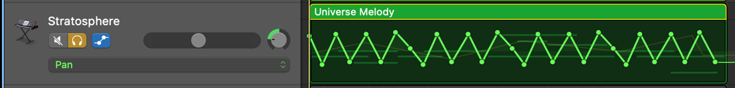

<Figure 6: Melody pan automation>

To further enhance this particular tone, I added a briskly oscillating Pan automation to create the effect of the wind blowing from both sides of the listener.

Melody #1 is a diatonically centered, rooted line that places its focus on the tonic note. While drifting from the supertonic to the close leading note, occasionally up to the dominant D, the tonic remains overt. In doing so, the melody evokes a sense of purpose, although ambiguous and at times uncertain.

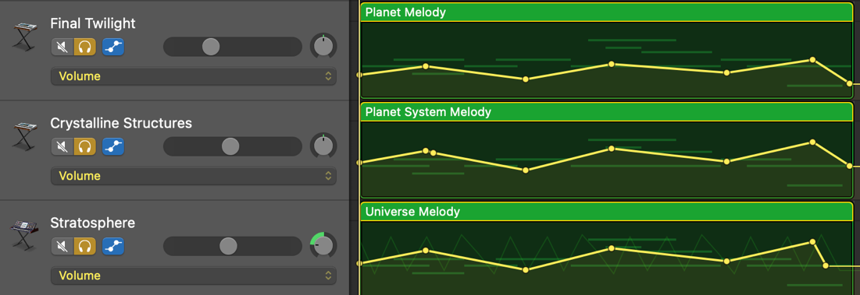

 <Figure 7: Melody volume automation>

Furthermore, the melodic section includes a swaying volume automation and can seamlessly looped, allowing the audience to introspect in their own time.

**Melody #2**

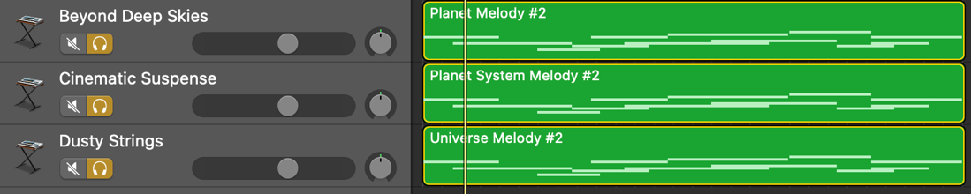

 <Figure 8: Melody #2>

**Planet Melody #2** - Beyond Deep Skies

Characterised by its light grating strings and its gentle white noise, the sound of *Beyond Deep Skies* fills the space with a soothing unpredictability and a calming intrigue, asserting itself as the base instrument for Melody #2.

**Planet System Melody #2** - Cinematic Suspense

With a smooth rich tone that vaguely resembles the timbre of a clarinet, *Cinematic Suspense* provides an especially harmonious and mellow sound to the melody. In combination with *Beyond Deep Skies,* the soundscape becomes fuller and more complete, paralleling the harmonious nature of a planetary system.

**Universe Melody #2** - Dusty Strings

Similar to *Beyond Deep Skies*, *Dusty Strings* feature a more abrasive strings section with a heavily wavering pitch bend. The general roughness of the tone suggests a certain eeriness about the unknown, magnifying the unexplored and mysterious aspect of the universe.

Melody #2 adopts a wider and a more open style, in which chords and intervals feature larger gaps between notes. Also consistently in the key of G major, the dominant and subdominant are prevalent while the mediant is neglected. Overall, this melody illustrates the universe's dispersed yet harmonious essence.

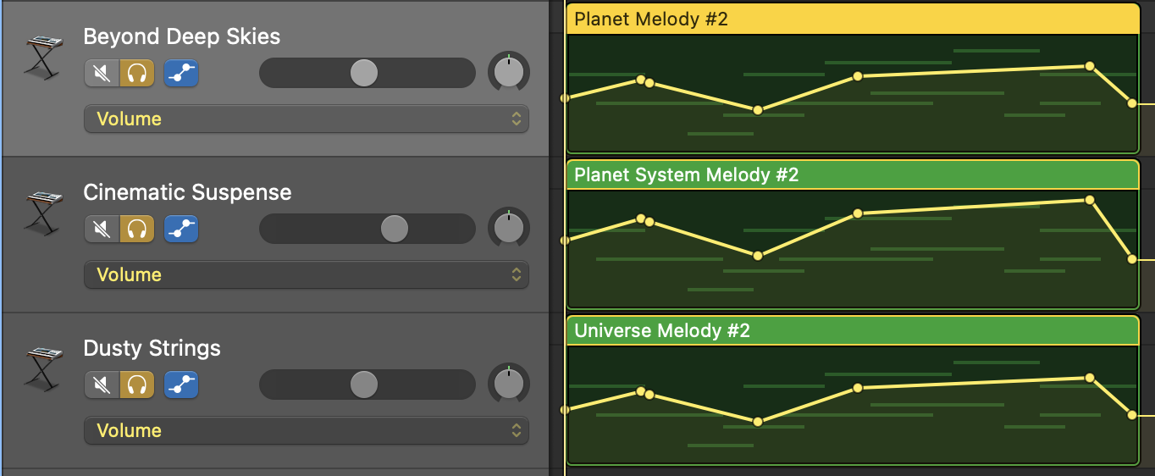

<Figure 9: Melody #2 volume automation>

Similar to Melody #1, all instruments have an undulating volume automation which can be fluidly looped, providing the listener a dynamic realm for thoughts.

**Effects**

In order to add certain aspects to the soundscape, special instruments with distinct lines were added. Through this addition, the soundscape is further enriched. Effects will be played alongside the "Universe" scale to showcase its grand diverseness.

 <Figure 10: Effects section>

**Air Bells**

After increasing the reverb, delay and decay for a longer echo, *Air Bells* produces a bright ring of a bell that penetrates the soundscape. Exactly as the numerous twinkling stars catch one's eye in the Universe (or on the website), this sound corresponds to these sparkles and is played sparingly to illustrate their enigmatic appearances.

**Shifting Panels**

With its Ethereal pulsating synthesizers with a firm attack, Shifting Panels is able to create dynamic movement within the ambient. In doing so, the universe is reinforced as an enchanting shape-shifting environment full of wonders capable of igniting one's curiosity.

<Figure 11: Effects pan automation>

To further enhance the sense of motion, a Pan automation is added, directing the throbbing electronic tones to oscillate between both sides of the listener.

**User Interaction**

The proposed sound design will be an optional feature embedded with "Eyes on Exoplanets", where the user is able to mute or adjust the sound volume freely. This sound design is in the form of a stereo audio, which the user will experience optimally using headphones, where the Panning of left-right audio is more effective. This will be recommended to users before the track begins.

As previously mentioned, the soundscape will vary as the user zoom in or out of planet systems. In other words, the user's action can also dictate the sound played.

**Bibliography**

1. Ambient Music, R. (n.d.). *✨ Space Ambient Music • Deep Relaxation Space Journey [ 4K UHD ]*. [online] www.youtube.com. Available at: https://www.youtube.com/watch?v=nq4tT68UoCg [Accessed 22 Oct. 2023].
2. Dale, J. (n.d.). *An introduction to Ambient Music*. [online] sites.barbican.org.uk. Available at: https://sites.barbican.org.uk/ambientmusic/.
3. Hill , S. (1983). *Hearts of Space*. [online] Hearts of Space. Available at: https://v4.hos.com/home [Accessed 22 Oct. 2023].
4. iZotope (2018). *Understanding Atmosphere in Music, and How to Create It*. [online] iZotope. Available at: https://www.izotope.com/en/learn/understanding-atmosphere-in-music-and-how-to-create-it.html.
5. KHEMLANI, A. (n.d.). *The Spiritual Revolution of Ambient Music - to Be Magazine*. [online] The Spiritual Revolution of Ambient Music. Available at: https://tobemagazine.com.au/the-spiritual-revolution-of-ambient-music/ [Accessed 22 Oct. 2023].
6. NASA (n.d.). *Discoveries Dashboard | Discovery*. [online] Exoplanet Exploration: Planets Beyond our Solar System. Available at: https://exoplanets.nasa.gov/discovery/discoveries-dashboard/ [Accessed 10 Oct. 2023].
7. NASA (2010a). *Eyes On Exoplanets – Exoplanet Exploration: Planets Beyond our Solar System*. [online] exoplanets.nasa.gov. Available at: https://exoplanets.nasa.gov/eyes-on-exoplanets/?destinations=/alien-worlds/strange-new-worlds/#/earth/ [Accessed 22 Oct. 2023].
8. NASA (2010b). *Eyes on Exoplanets Web Application*. [online] Exoplanet Exploration: Planets Beyond our Solar System. Available at: https://exoplanets.nasa.gov/eyes-on-exoplanets-web/ [Accessed 10 Oct. 2023].
9. Steblin, R. (1983). *Musical Key Characteristics*. [online] wmich.edu. Available at: https://wmich.edu/mus-theo/courses/keys.html.
10. Tornow, S. (2019). *Ambient in Outer Space: Seven Artists Exploring the Final Frontier*. [online] Bandcamp Daily. Available at: https://daily.bandcamp.com/lists/outer-space-ambient-list [Accessed 22 Oct. 2023].
11. Wikipedia. (2021). *Space-themed music*. [online] Available at: https://en.wikipedia.org/wiki/Space-themed_music.
12. Wikipedia. (2023a). *Ambient music*. [online] Available at: https://en.wikipedia.org/wiki/Ambient_music#Space_music [Accessed 22 Oct. 2023].
13. Wikipedia. (2023b). *Space music*. [online] Available at: https://en.wikipedia.org/wiki/Space_music [Accessed 22 Oct. 2023].